GAURAV_BODKHE_2124UCEM1041

ASSIGNMENT NO.1

1. Introduction
We have to Install the Android SDK and developer tools and build a test project to confirm that those tools are properly installed and configured.

2. Tools & Technologies Used
- Android Studio
- Kotlin (DSL)
- Emulator

3. Procedure & Steps

Step 1: Create a New Project
- Open Android Studio and create a new project.
- Choose an Empty Activity template.
- Set the project name and package name.
- Select the programming language (Kotlin).
Screenshot:
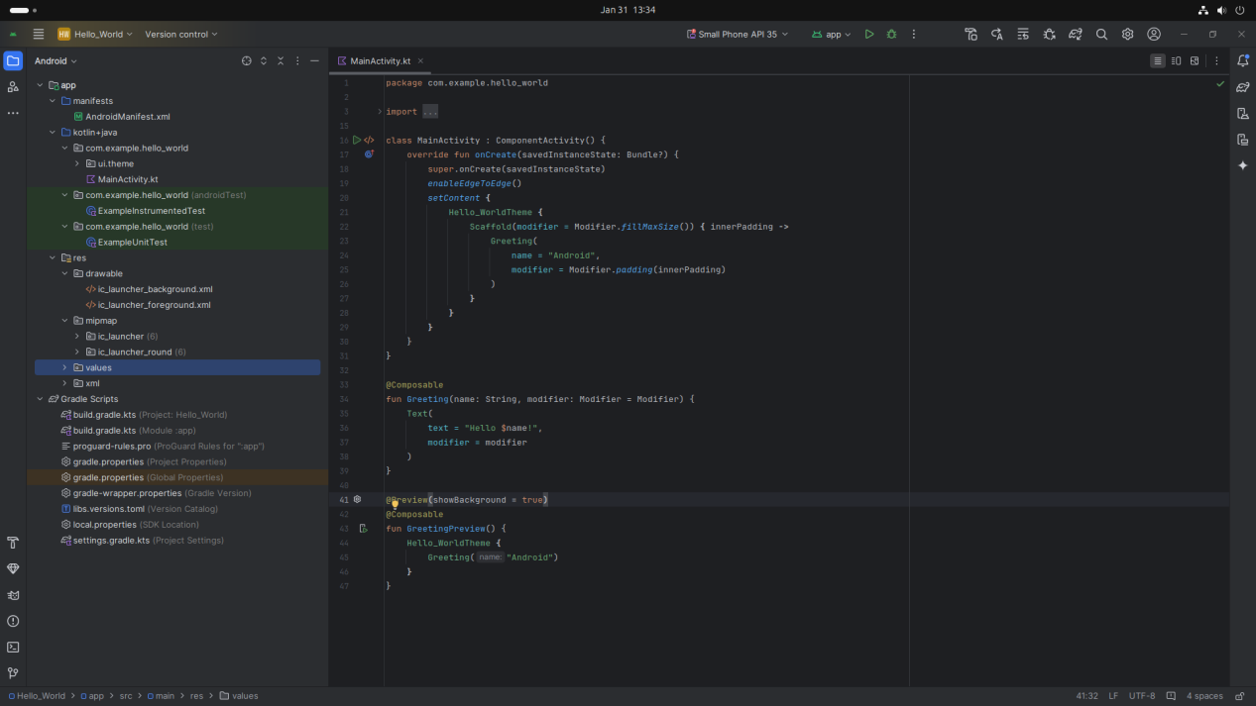

Step 2: Designing the UI
- Open activity_main.xml and design the layout using XML.
- Add UI comwponents such as TextView, EditText, Button, etc.

Screenshot:
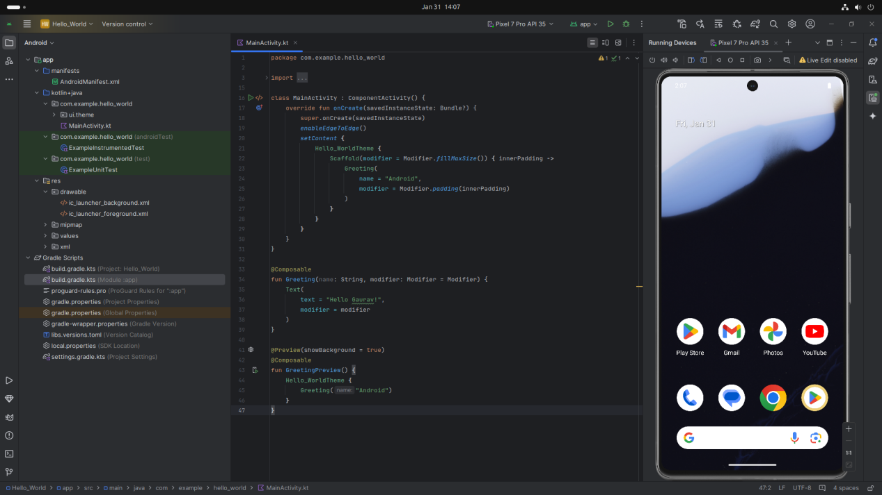

Step 3: Writing the Code
- Open MainActivity.kt.
- Implement functionality such Hello Gaurav etc.
- Use necessary Android components like Intents, RecyclerView, Fragments, etc.

Kotlin
package com.example.hello_world

import android.os.Bundle
import androidx.activity.ComponentActivity
import androidx.activity.compose.setContent
import androidx.activity.enableEdgeToEdge
import androidx.compose.foundation.layout.fillMaxSize
import androidx.compose.foundation.layout.padding
import androidx.compose.material3.Scaffold
import androidx.compose.material3.Text
import androidx.compose.runtime.Composable
import androidx.compose.ui.Modifier
import androidx.compose.ui.tooling.preview.Preview
import com.example.hello_world.ui.theme.Hello_WorldTheme

class MainActivity : ComponentActivity() {
override fun onCreate(savedInstanceState: Bundle?) {
super.onCreate(savedInstanceState)
enableEdgeToEdge()
setContent {
Hello_WorldTheme {
Scaffold(modifier = Modifier.fillMaxSize()) { innerPadding ->
Greeting(
name = "Android",
modifier = Modifier.padding(innerPadding)
)
}
}
}
}
}

@Composable
fun Greeting(name: String, modifier: Modifier = Modifier) {
Text(
text = "Hello Gaurav$name!",
modifier = modifier
)
}

@Preview(showBackground = true)
@Composable
fun GreetingPreview() {
Hello_WorldTheme {
Greeting("Android")
}
}
Screenshot:
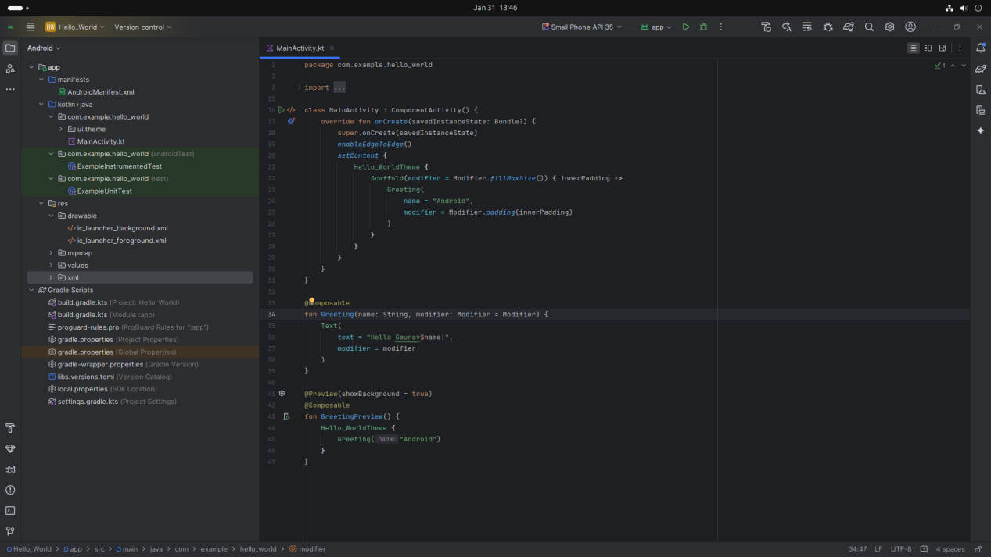

Step 4: Running the Application on Emulator
- Click on the Run button in Android Studio.
- Select the emulator and launch the app.
Screenshot:
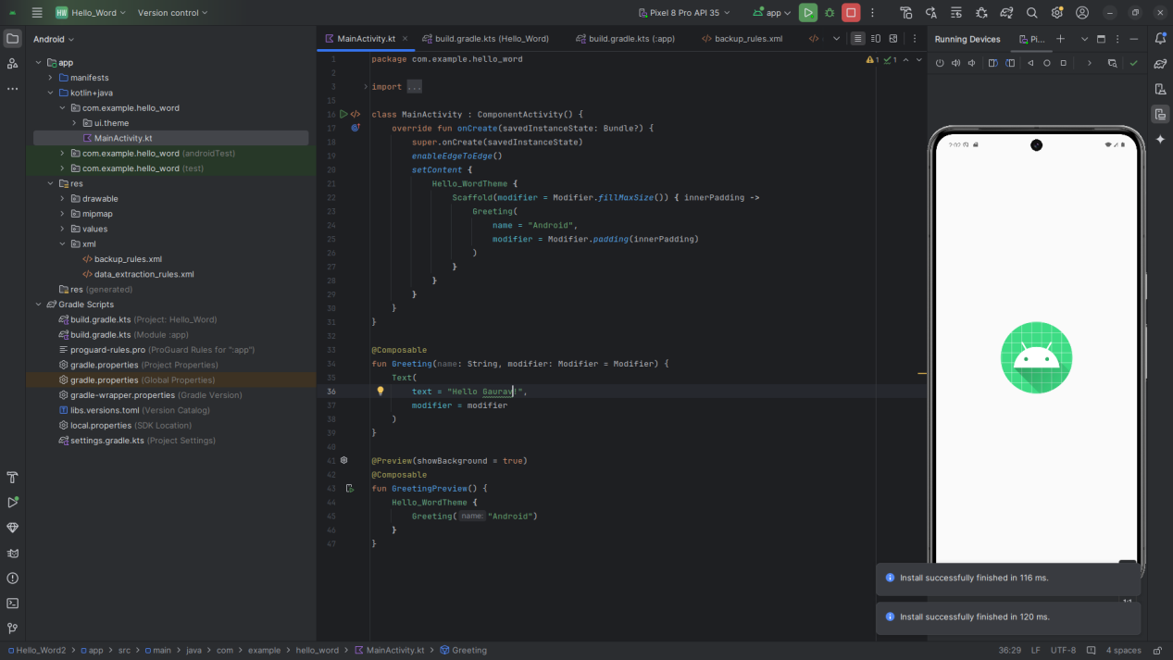

Step 5: Testing & Output
- Rest different functionalities of the app.
- Capture the output results.

Screenshot:
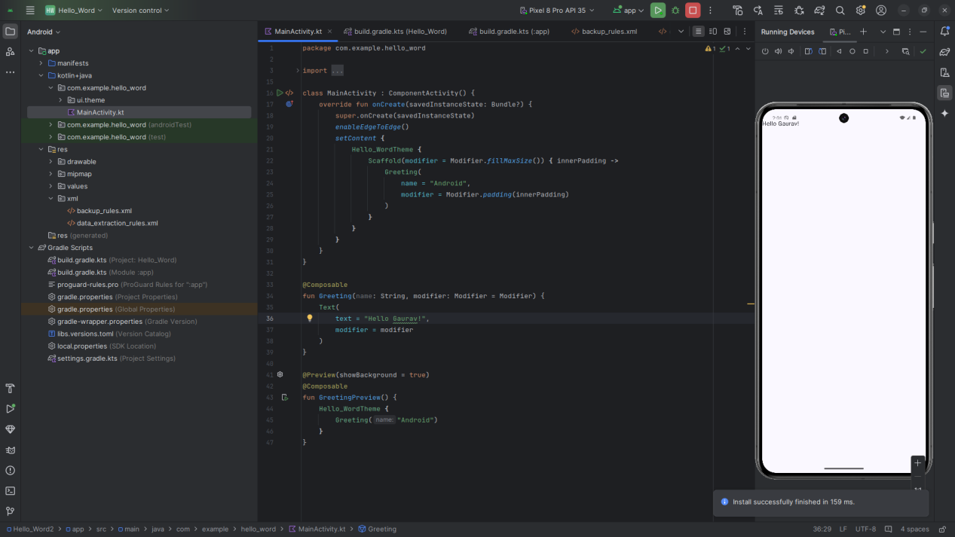

4. Conclusion
I learned a lot about to Install the Android SDK and developer tools and build a test project and gained new skills like how to build simple Hello World App on Android Studio . Some challenges I faced included how to resolve error of androuid 34 and how to make changes in code but I was not able to solve them but I Explain this issue to our subject teacher and he helped me to ressolve this error
In the end, I feel more confident and better prepared to use what I’ve learned in the future. The experience also taught me how to problem-solve and manage my time better.

